1. Write a Java program to

a. Search an item through linear search

**import** java.util.Scanner;

**public** **class** Operation_in_array {

**public** **static** **int** linearSearch(**int**[] a1, **int** num){

**for**(**int** i=0;i<a1.length;i++){

**if**(a1[i] == num){

**return** i;

}

}

**return** -1;

}

**public** **static** **void** main(String a[]){

**int**[] a1= {10,20,30,50,70,90};

Scanner sc= **new** Scanner(System.***in***);

System.***out***.println("enter your no:");

**int** num = sc.nextInt();

System.***out***.println (num+ " is found at index: " +*linearSearch*(a1, num));

}

}

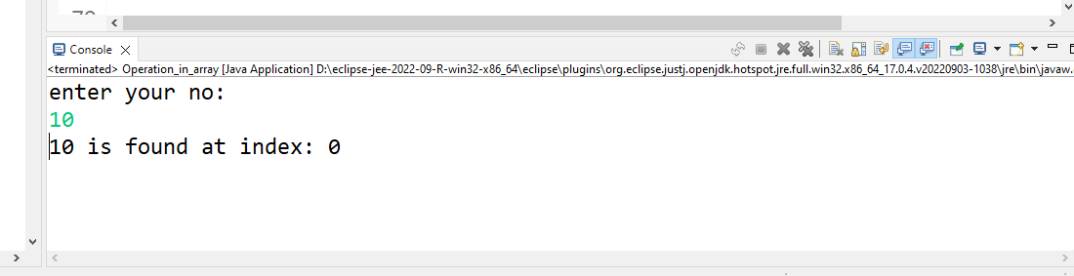

2

**import** java.io.*;

**class** BinarySearchTree {

**class** Node {

**int** key;

Node left, right;

**public** Node(**int** item)

{

key = item;

left = right = **null**;

}

}

Node root;

BinarySearchTree() { root = **null**; }

**void** deleteKey(**int** key) { root = deleteRec(root, key); }

Node deleteRec(Node root, **int** key)

{

**if** (root == **null**)

**return** root;

**if** (key < root.key)

root.left = deleteRec(root.left, key);

**else** **if** (key > root.key)

root.right = deleteRec(root.right, key);

**else** {

**if** (root.left == **null**)

**return** root.right;

**else** **if** (root.right == **null**)

**return** root.left;

root.key = minValue(root.right);

root.right = deleteRec(root.right, root.key);

}

**return** root;

}

**int** minValue(Node root)

{

**int** minv = root.key;

**while** (root.left != **null**) {

minv = root.left.key;

root = root.left;

}

**return** minv;

}

**void** insert(**int** key) { root = insertRec(root, key); }

Node insertRec(Node root, **int** key)

{

**if** (root == **null**) {

root = **new** Node(key);

**return** root;

}

**if** (key < root.key)

root.left = insertRec(root.left, key);

**else** **if** (key > root.key)

root.right = insertRec(root.right, key);

**return** root;

}

**void** inorder() { inorderRec(root); }

**void** inorderRec(Node root)

{

**if** (root != **null**) {

inorderRec(root.left);

System.***out***.print(root.key + " ");

inorderRec(root.right);

}

}

**public** **static** **void** main(String[] args)

{

BinarySearchTree tree = **new** BinarySearchTree();

tree.insert(50);

tree.insert(30);

tree.insert(20);

tree.insert(40);

tree.insert(70);

tree.insert(60);

tree.insert(80);

System.***out***.println(

"Inorder traversal of the given tree");

tree.inorder();

System.***out***.println("\nDelete 20");

tree.deleteKey(20);

}

}

output

